PLANNING APPEAL STATEMENT FOR

USE OF ONE ADDITONAL BEDROOM IN
AN EXISTING C4 HMO. C4 TO SUI GENERIS

11 BEECH AVENUE NOTTINGHAM, NG7 7LJ



PREPARED BY
MIKE SMITH
DIRECTOR

NOTTS RELOCATE LTD &
MS BLOCK HOLDINGS LTD

APPENDIX

0 – Planning Case Approval for 39 Beech Avenue (approval of 5 HMO rooms inc. a dormer)
1 – Planning Case Approval for 42 Nottingham Rd (additional bedroom in existing HMO)
2 – Site Plan showing location & local streets
3 – Planning Inspectorate Appeal for 159 Colwick Rd (C3 Dwellinghouse to HMO)
4 - Planning Inspectorate Appeal for 13 Sneinton Boulevard (C3 Dwellinghouse to HMO)
5 – Planning Inspectorate appeal for 70 Colwick Rd (C3 Dwellinghouse to HMO)
6 – Planning Approval for 10 Sedgley Avenue (C3 Dwellinghouse to HMO)
7 – HMO Register Supporting Data (Sept 2023)
8- HMO Team Kitchen Amenity standards (from Nottingham City Council)
9. Email from Ryan Clifford HMO Team 28th Nov – Confirming shared space in house meets HMO Amenity standards Regulations.
10. Refusal Notice from Council.
11. Additional email from the HMO Team confirming that the house fully meets the HMO space standards for a 7 bed.

- APPEAL INTRODUCTION
1.1 I hereby submit an appeal against Nottingham City Councils decision to refuse planning application reference 24/01091/PFUL3 (PP-13132807) for a change of use from 6 bed HMO (Use Class C4) to 7 bed HMO (Sui Generis) at 11 Beech Avenue, Nottingham, NG7 7LJ
  - The case for this appeal is respectfully set out below.

- APPEAL SITE AND SURROUNDINGS
2.1 The redline site area consists of a 7-bedroom, three storey, Semi Detached HMO property which has been a C4 HMO for many years. The previous operator utilised the house informally a 7 bed in the past, although formal records have been hard to obtain.

2.2 The Semi Detached HMO has 7 bedrooms, a lounge, 2 kitchens and 3 bathrooms and all of the associated HMO safety features. The house far exceeds the Kitchen amenity standards (Appendix 7) Nottingham City Councils HMO Team require for 7 people.

2.3 The house will retain a lounge with this proposed change. The house is a large 182m2.

2.4 The Semi Detached HMO has it’s own private driveway and a small open yard. The HMO is not connected to any other property on the side with the HMO bedrooms.

2.5 The HMO is located on Beech Avenue, a busy street which has a mixture of Commercial units, Residential buildings and ample unrestricted on street parking. It is next to a major bus route on Sherwood Rise, so a sustainable location.

2.6 The area is not known as a student area and Beech Avenue and the nearby streets have only 4.8% HMOs (as evidenced by analysing the HMO register – see section 7.4a which has the analysis of NCC’s HMO register data) The Council on 3rd Sept 2024 accepted the veracity of this analysis. Furthermore on the refusal notice (Appendix 10) The Council also state that the area, “Beech Avenue is not considered to represents a 'significant concentration' (of HMOs) in this instance” as with the adjoining areas it does fall below the 10% threshold that the Council state would usually trigger a refusal” thus the area has a low number of HMOs.

3. PLANNING HISTORY
3.1 Prior to the submission of this application, there was one application in 1990 for conversion into 3 flats. It was refused in 1990.

4. APPLICATION LEADING TO APPEAL

4.1 The application is to increase the number of occupants from 6 occupants (C4 Class) to 7 occupants (Sui Generis Class) and utilise underused space in an existing C4 HMO.

4.2 The Appellant proposes no internal works of any kind to the HMO. The HMO has been a 7 bed house for many years and it will simply mean one extra tenant lives at an existing HMO which was informally used as a 7 bed in the past.

4.3 Informally the room was let for many years by the previous operator with no community concerns, but following the Appellant taking over management and determining the licence was for 6 people, he applied to the City Council to formalise the use of the room including this application. Due to the previous operator’s lack of record keeping, the Appellant is unable to apply for a Certificate of Lawful Use and therefore seeks to formally obtain consent to change the use of the property from C4 to Sui Generis.

4.4. Due to the property being utilised as a HMO for years, the dwelling is not considered suitable for family occupation due to alterations that had been undertaken such as a large number of rooms, installation of fire doors, fire alarms and multiple kitchens (2 kitchens).

4.5 The HMO provides keyworker accommodation for overseas NHS staff working at City Hospital and Graduates. This type of affordable accommodation for keyworkers is becoming increasingly in short supply due to the cost of living crisis. The Appellant is restricting its occupants to professionals and graduates. The Appellant will personally manage the property and the property will be professionally cleaned on a weekly basis. The Appellant has also ensured that he has introduced himself and has given his contact details to the neighbours, who are then able to identify any issues that may arise, in order to ensure effective long-term management of the property.

4.6 From an analysis of the NCC HMO Dataset (see appendix 7) the streets / area surrounding Beech Avenue have a low number of HMO’s. The average is only 4.8%, see the full analysis in section 4.7a. Adding another room to an existing HMO will clearly provide much needed affordable accommodation for an NHS keyworker or Graduate in an area with low numbers of HMOs. Nor will adding another room to an existing HMO increase the overall % of houses being HMOs in the area.

4.7 This is supported by Chapter 5 of the National Planning Policy Framework (Dec 2023) relates to ‘Delivering a sufficient supply of homes’ and identifies the key objective which is to “significantly boosting the supply of homes, it is important that a sufficient amount and variety of land can come forward where it is needed, that the needs of groups with specific housing requirements are addressed and that land with permission is developed without unnecessary delay.” It is considered that the application provides an additional unit for somebody to live in.

4.8 Chapter 11 (d) of the NPPF (Dec 2023) also states that Councils should “promote and support the development of underutilised buildings”. Allowing the use of a spare room in an existing HMO would clearly support this objective.

4.9 . The Nottingham Housing Strategy for the City “Quality Housing for All” states at page 3 that the “Housing Nottingham Plan to deliver effective housing interventions across all tenures. “Whilst it is understood that there is a need to retain family accommodation across the city, there is also a need to housing of varying tenures and it is considered that there is a lack of high quality accommodation suitable for professionals and graduates to meet the needs of local and national businesses within the locality”. Given the house provides accommodation to key workers and graduates, it would meet a local need.

5. REASONS FOR REFUSAL
5.1 On 13th Sept 2024 application 24/01091/PFUL3 (PP-13132807) (Appendix 10) was refused for the following reasons:
a. The proposal is likely to result in an unbalance community with too many HMOs, problems associated with noise and disturbance, property upkeep, waste disposal, on street parking, a high turnover of occupants and the absence of residents outside of term time. These factors would be detrimental to both the amenities of neighbouring occupiers and the surrounding area in general, contrary to Policy 10 of the ACS and Policies HO6, DE1, DE2 and IN2 of the LAPP.
b. The proposed increase in occupancy would reduce the amount of communal space per occupant, reducing the overall standards of amenity for future occupiers. The proposal would therefore fail to provide a satisfactory quality of living environment, in conflict with Policy 10 of the ACS and Policy DE1 of the LAPP.

6. PLANNING PRINCIPLES
6.1 It is respectfully submitted that on review of the Councils reason for refusal of application 24/01091/PFUL3 (PP-13132807) (Appendix 10) , the principal planning considerations within this appeal are:

Would the approval of an extra bedroom in an existing HMO create an unbalanced and unsustainable community?

Would the development create an unacceptable amount of communal space per occupant and unsatisfactory quality of living environment?

Would the approval of one additional bedroom in an existing 6 Bed House of Multiple Occupation have a materially detrimental impact on the amenities of neighbouring occupiers through increased noise and disturbance?

6.2 The submissions below will seek to demonstrate that the proposed development has taken into full consideration the site constraints and has presented for approval an appropriate development that would not have a detrimental impact upon the residential amenities of the neighbouring occupiers, will not create an unbalance community. The submissions will clearly demonstrate that the amenity standards already meet Nottingham City Council’s published HMO standards.

7. PLANNING SUBMISSIONS

Would the approval of an extra bedroom in an existing HMO create an unbalanced and unsustainable community?

7.1 Policy HO1 and HO2 of the Part 2 Adopted Local Plan sets out that there will be a presumption against the loss of family dwelling houses and that any development, the purpose of these policies are to prevent the loss of family homes in the area and to encourage more family homes. As the house is an existing C4 HMO and no dwelling house is being lost the Council fully acknowledge in their refusal notice that the proposal is in fully compatible with H01 and H02. Therefore, there is no conflict with the Councils HO1 and HO2 policies.

7.2 Of importance in this regard is also the compliance with Policy HO6 which Houses in Multiple Occupation (HMOs). Policy HO6 states: “In assessing the development’s impact on local objectives to create or maintain sustainable, inclusive and mixed-use communities, regard will be given to the following criteria: the existing proportion of HMOs and / or other Student Households in the area and whether this proportion amounts or will amount to a ‘Significant Concentration’ apart from PBSA within areas identified in Policy HO5 where new PBSA is encouraged;” A ‘Significant Concentration’ is defined in the Council’s policy as 10%.

7.3 Paragraph 4.60 of the Local Plan states that: “The application of a 10% threshold is considered to strike an appropriate balance between meeting HMO and student accommodation needs within the City and supporting the objective of creating sustainable, inclusive and mixed communities.” The application of the 10% threshold is also acknowledged in the Council’s refusal notice.

7.4 Utilising the Council’s HMO register which is available online on the Council’s website, an analysis was undertaken to determine the existing proportion of HMOs on Beech Avenue and the surrounding area.

Figure 7.4a HMOs Concentration in the Local Area
Complied using the NCC HMO Public Register, Sept 2023.

Street Name | Number of Houses on Street | Number of HMOs on NCC Register | % HMO
Beech Avenue | 84 | 8 | 9.5%
Sherwood Rise | 63 | 3 | 4.7%
Alma Street | 50 | 0 | 0%
East Grove | 22 | 0 | 0%
Falcon Street | 16 | 0 | 0%
Hamilton Rd | 75 | 3 | 4%
Ebury Rd | 66 | 4 | 6%
Alberta Terrace | 56 | 4 | 7.1%
Alexandra Rd | 41 | 1 | 2.4%
Fourth Avenue | 18 | 1 | 5.5%
AVERAGE | 491 | 24 | 4.8%

7.5 A map attached (Appendix 2) shows the area included within this search in relation to the appeal site. As can be seen from the data above, within the area immediately surrounding the application site, only 4.8% of the properties are classified as a HMO’s. It is therefore considered that the approval of allowing one more tenant stay in an existing HMO will not create an unreasonable ‘significant contribution’ of HMO’s within the locality as this falls well below the 10% figure stipulated by this policy.
7.6 The Council clearly support this finding and acknowledge in their refusal notice clearly that “in this instance that the area is not considered to be a significant concentration”. It was also stated that “the average including the adjoining Output Areas is 7.3% student or HMOs properties” is the reason that it was not deemed to be a significant concentration.
7.7 The Council’s 7.3% figure (which still is well below the 10% threshold) was produced using Council Tax Exemption Records which includes students living in Flats as well as HMOs. This makes little rational sense as the Council has no planning rules against one or two students in flats. Thus the Council’s 7.3% calculation is an inflated figure of the concentration of HMOs and potential associated issues. Any claim made the areas is marginally “close” to the 10% threshold, thus is not objectively correct. The 4.8% HMO figure is clearly the most accurate representation of HMO concentration which shows the area is not remotely close to 10%. It thus is an area with significantly low numbers of HMOs and a long way from the 10% threshold.
7.8 As both methods clearly show an area well below the 10% threshold, allowing just one more tenant in an existing HMO would not undermine the HO6 policy aim and would ‘strike an appropriate balance between meeting HMO’ needs and ‘supporting the objectives of creating sustainable, inclusive and mixed communities’. It would also provide valuable accommodation for NHS workers & graduates, an identified local housing need.
7.9. The refusal notice makes an unsubstantiated claim that should the appeal be allowed there would then be “no upper limit on the number of occupants permitted within the property of use without further planning control”. This is not objectively true as, for example:
- All Bedrooms and amenities must meet the Council’s HMO Team’s Minimum Room sizes and Amenity standards thus it would be impossible to have “no upper limit”.
- e.g. Under Building Regulations & HMO regulations every bedroom is required to have a window. New window openings would require Planning Permission thus planning control clearly does apply to further development and the “no upper limit” comment is vexatious.
- Permitted Development rights that apply to a C3 Dwellinghouses do not apply to a Sui Generis HMOs so more rooms cannot be added without significant further development which would require planning control.
- The application is for a 7 Bedroom HMO hence the title “7 bedroom HMO” and it can be approved on this basis. There is no intention to increase the numbers beyond this.
- Under both data methods (HMO Data & Exemption Data) it would not result in any % change towards the 10% concentration figure as no new house is being made into a HMO. Thus, it could not be argued approving this appeal would bring the area to closer to the threshold.

7.10 The Councils example given in the refusal notice that “the lounge could be turned into a 8th bedroom” with ease is not objectively correct. The HMO Team Amenity Space standards (see appendix 8) clearly show in properties where there is no dining or lounge space (there is no other shared space other than 2 kitchens) rooms would need to be a minimum of 10m2. The lounge is only 8.6m2 and so thus the lounge would not qualify as large enough to be bedroom if it was removed and only the 2 kitchens remained. Therefore the ‘example’ given by The Council is vexatious and clearly demonstrates clearly that future development is significantly constrained by the HMO amenity standards.

7.11 Therefore, further intensification is evidently significantly constrained by planning control and no evidence has been given by the Council to demonstrate it being “uncontrolled”. Thus, there is no evidence presented that allowing the development would breach the Councils H06 Policy, as the area is clearly in an area with very low number of HMOs. Just 4.8% if the more accurate HMO dataset is used.
7.12 At 39 Beech Avenue, NG7 7LL. Application 23/01348/PFUL3 (PP-12352843) (see appendix 0) a significant intensification of an existing HMO (5 extra rooms) was deemed to be compatible with Policy HO6 in 2023. The Council states “in the circumstances of the previous use and the HMO licence, the proposed use is acceptable. The provision of a dormer which would improve the residential facility is also acceptable”. This added 5 additional HMO rooms to the locality in a location just 50m away from the appeal site. Thus the intensification concerns at 11 Beech Avenue, are inconsistent with this decision which allowed an intensification of 5 rooms to be added to an existing HMO under the HO6 Policy. It trusted for matters of consistency the same principles will apply.
7.13 In Application Number: 20/01227/PFUL3 (PP-08790185) intensification one of room was allowed 42 Nottingham Rd (See Appendix 1) where an additional room was approved by NCC in an existing 6-bedroom HMO to make it 7 rooms. This application has many similarities to this application due to the size of the house and very close proximity. The proposal was accepted by the Council as an extra tenant “could be absorbed into the existing use without it being materially evident”. For matters of consistency, it is trusted that the same principles will apply.
7.14 In addition to the evidence above and the 42 Nottingham Rd (see appendix 1) case study listed in Section 4.4, it is important to note other relevant Planning Inspectorate appeals on properties within Nottingham where the HMO concentration is low. The Planning Inspectorate have gone much further and even allowed full C3 to C4 applications to be accepted in areas with a concentration below 10%. This is a much more significant change to an intensification of HMO rooms than this appeal seeks to make.

Appeal ref: APP/Q3060/W/19/3232422, issued in October 2019, related to no 159 Colwick Road, Nottingham (See Appendix 3). The Inspector allowed a C3 house to become a C4 HMO and concluded that:
“There is no evidence before me to suggest that that this particular part of the city has a high concentration of HMO’s or an imbalance of family housing. I therefore conclude the proposed development would not lead to an overconcentration of HMO development within the area and have an unacceptable effect on the availability of family housing to the detriment of a balanced and sustainable community in the locality.”

7.15 Appeal ref: APP/Q3060/W/17/3181825 relating to 13 Sneinton Boulevard (see appendix 4) The Inspectorate concluded that:
“I note the appellant’s evidence that the property is in an area with a low proportion of student HMOs and the Council has not disputed the figures provided. I conclude that the development would not have a detrimental effect on the maintenance of a balanced community…Whilst these policies support the provision of family house, they do not preclude the provision of other types of accommodation.”

It is considered that in light of the evidence above of low numbers of student HMOs (4.8% in the Beech Avenue area), the same principle would apply to this appeal and the approval of just another room in an existing HMO would not have a detrimental effect on the maintenance of a balanced community which has a very low number of HMOs.

7.16 Another important and recent appeal decision was ref APP/Q3060/W/19/3227773 for no 70 Colwick Road which was allowed in July 2019 (see appendix 5). The Inspector concluded that: “The Planning Officer’s report acknowledged that properties along this part of Colwick Road are, with very few exceptions, in use as Class C3 family dwellings. I consider that the development does not result in an over-concentration of HMO’s in the area and as a consequence, it does not lead to an unacceptable loss of family accommodation.”

7.17 This appeal decision again adds weight to this appeal and should be a material planning consideration in the determination of this application.

7.18 It is also noted that the Council have accepted other C3 to C4 applications (without the need to appeal) on the basis of the area having a very low number of HMO’s in that area. The Delegated Report for 10 Sedgley Avenue (see appendix 6) under application reference 18/00505, states that the Council accepted the development on the basis of there being a low number of multiple occupancy properties in the area it is not considered that use as an HMO would detrimentally impact on the sustainability and balance of the community. It is also understood (although firm evidence does not exist), that the property has been rented out for many years, commonly as an HMO rather than a C3 dwellinghouse. The proposal is therefore considered to comply with Aligned Core Strategy Policy 8 and Local Plan Policy ST1”. (Nottingham City Council, 2018)

7.19 This appeal for no 11 Beech Avenue seeks to simply add a room to an existing HMO, a significantly lower impact to the balance of the community than the above approved planning inspectorate cases which were for full C3 to C4 applications and added a significant number of HMO rooms to a locality. Thus it is trusted for matters of consistency that the same principles will apply in a similar area of low numbers of student HMOs that juts one additional room will be allowed.

7.20 The formal decision notice (Appendix 10) did not reference recent decisions but on email Zoe Kyle, the planning officer, attached two cases she stated were ‘relevant’. 24/00499/PFUL3 – 72 Highfield Road and 24/01018/PFUL3 – 19 Larkdale Street. These cases are not relevant to the appeal site as they were in Nottingham’s main student area where the % of student households were 74.4% (Highfield Rd) and 41% (Larkdale Street) thus a reasonable argument could be made that those other areas have some degree of studentification issues. This is significantly higher than the 7.7% on Beech Avenue using the same metric and shows fundamentally that it is not a relevant comparison.
Highfield Rd has nearly 10X the number of student households! The location of 72 Highfield Rd is also 4.5 miles drive away and has little relevance geographically.

7.21 The more relevant 42 Nottingham Rd (Appendix) case which is 100m away and in an area with similar number of HMOs and 39 Beech Avenue (Appendix – 0) which were both approved by NCC (without a need for appeal) are significantly more relevant to the specific characteristics of the appeal site in geography numbers of HMOs. Overall, the weight of evidence from previous cases does indicate that the appeal should be allowed for matters of consistency.

Would the development create an unacceptable amount of communal space per occupant and unsatisfactory quality of living environment?

8.1 The house fully meets the Council’s HMO own published amenity standards (Appendix 8) which objectively are the best measure to use. It appears the Planning Department have misunderstood the number of kitchens at the house and the need for dining space. There are two kitchens at the property – see below the measurements and photographic evidence:

- Kitchen 1: 3.6 x 2.6: 8.60m2
- Kitchen 2: 3. 6 x 3.35: 12.06 m2

Figure 8.1a Photographic Proof of the two kitchens.

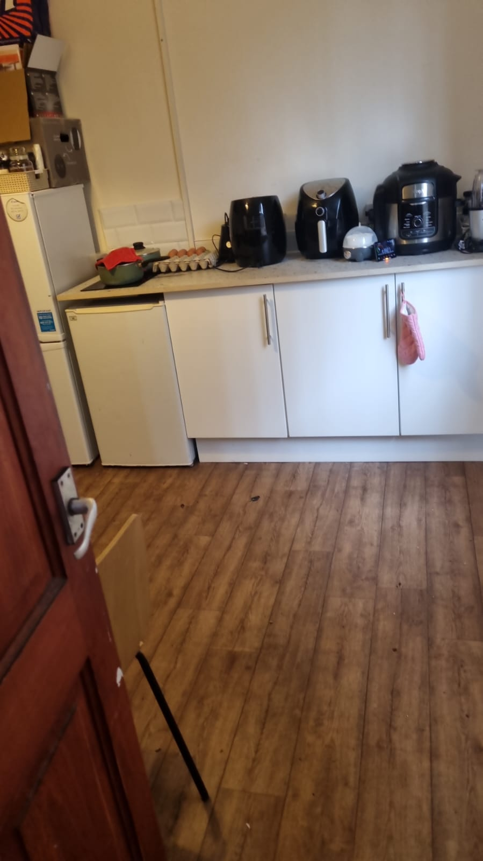
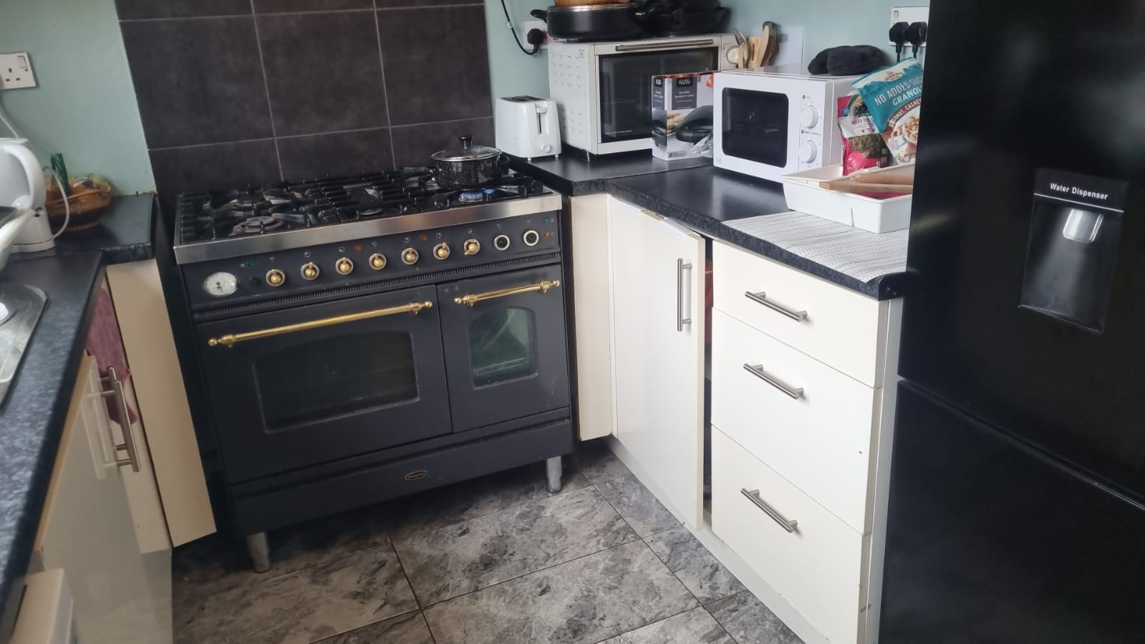

The HMO amenity standards require just 9m2 (see appendix 8) of kitchen space for 7 occupiers. The house has 20m2 which is more than double the requirements for kitchen space.

8.2 The published HMO Amenity standards (appendix 8) show very clearly that the house meets the dining space standards, separate dining rooms only are required “where needed” i.e. when rooms are below 10m2 and where a house does not have suitable kitchen or lounge space. As all of the rooms are above 10m2 and the house has 20m2 of kitchen space (double the requirements!) a separate dinning room is not needed as per the amenity standards.

8.3 Ryan Clifford of the Nottingham HMO team (Appendix 9) was contacted on 18th Nov to confirm that it would not require a dining room and that the shared space was satisfactory for a 7 bed HMO? On 28th Nov Ryan Clifford confirmed in writing that clearly that the house fully meets the standards in relation to shared space if it was a 7 bed HMO. No dinning space was needed as all rooms are above 10m2 (Appendix 9).

8.4 Another HMO Officer Mark Phips also replied (Appendix 11) confirming that the only requirement for dinning space would be if house didn’t have enough kitchen space. As the house has a 20m2 kitchen (double the published requirements!) it was stated clearly it would meet all the relevant shared space standards for a 7 Bed HMO. Thus the Council vexatious comment that it does not meet the amenity standards, is demonstratably false.

8.5 In the refusal notice the Planning Dept state that they believe 28.6m2 shared space is small. This is entirely an arbitrary comment, not based upon any evidence or any HMO amenity standard that the Council’s HMO Team have ever published. It is entirely vexatious, arbitrary and not an objectively true comment.

8.6 Thus the house fully meets all of Nottingham City Councils Published HMO Shared Space amenity standards and the Planning Department have misunderstood the HMO regulations.
Thus the living environment thus is fully compliant in providing future occupiers with a high quality environment and meets all the relevant planning policies.

Would the approval of one additional bedroom in an existing 6 Bed House of Multiple Occupation have a materially detrimental impact on the amenities of neighbouring occupiers through increased noise and disturbance?

9.1 No objections were received from the community consultation.
9.2 There is no evidence presented by the Council to materially prove that just one extra occupier (e.g. an NHS Nurse) in an existing professional C4 HMO would cause additional concerns regarding low level anti-social behaviour, noise issues, problems with litter, waste disposal and property maintenance. Given the area has a very low 4.8% (7.7% if the Councils inflated figures are accepted) it is unlikely that the community would experience the issues of ‘studentification’ that could in theory occur in areas with a significant % of students.

9.3 In the past the HMO the property had been previously occupied by 7 people for sometime. Due to the previous owner’s lack of record keeping, the Appellant is unable to apply for a Certificate of Lawful Use. Given the history of the property, it is unlikely any neighbour would notice any material change by approving this appeal as in the past it was used as a 7 Bed HMO without community issues.

9.4 To ensure that the property is carefully managed, it is professionally cleaned on a weekly basis. This includes the management of the external waste areas to ensure that waste is managed appropriately and does not become an issue for neighbouring occupiers. There has been no past or current issues with the house and just one additional occupier will not cause any material change of the current situation. The Council have not provided any evidence to show that there would be materially change in waste arrangements.

9.5 The house is semi-detached with all the bedrooms on the Eastern side of the property that are not connected to any other property. It is thus unlikely any neighbour will ever hear any additional noise from the addition of just one extra tenant when there are several walls and a large five meter gap between the properties. Any noise is likely to be less than if the property was occupied by a family who may have children playing in the garden making noise.

9.6 The Appellant has also ensured that he has introduced himself and has given his contact details to the neighbours who are then able to identify any issues that may arise. It is unlikely that noise would be an issue with the proposed occupiers being restricted to professionals only and is likely to be less than if the property was occupied by a family. The extra occupant would be restricted to a working professional, and it is noted that this area is not very suitable for students due to the distance from the universities and therefore there is unlikely to be any demand for student occupiers. The low numbers of students in this area demonstrated by this appeal prove this.
9.7 At 39 Beech Avenue, NG7 7LL. Application 23/01348/PFUL3 (PP-12352843) (see appendix 0) it was noted in the Council’s report “It is considered that the proposal would have an acceptable impact on neighbouring properties in terms of privacy, daylight, sunlight and outlook. The change to the manner of occupation of the flat is not considered to have any impact on neighbouring residents. The proposal therefore complies with Policy 10 of the Aligned Core Strategies and Policy DE1 of the Nottingham Local Plan”
Given that 39 Beech Ave, less that 50m away, was deemed to have no impact on neighbouring properties by intensifying the HMO rooms. It is considered that adding just one room to an existing HMO at 11 Beech Ave should have a lesser impact on the community than 39 Beech Ave where a significant intensification (5 rooms) were approved by the Council.
9.8 In Application Number: 20/01227/PFUL3 (PP-08790185) at 42 Nottingham Rd (Appendix 1) it was held that “Whilst it is considered that one further occupant in an HMO has the potential to add to existing problems in areas of high concentration, in the particular circumstances of this location it is considered that one additional occupier would be unlikely to be noticeable, and would not materially add to any potential noise or disturbance”.

This is further evidence that adding one extra occupier in an area with a low number of HMOs would unlikely to be noticeable. It is considered that 11 Beech Avenue is very similar to 42 Nottingham Rd (is very close by) and for matters of consistency it should be approved.

9.9 The house has its own private driveway which is suitable for up to two cars but is rarely utilised by the tenants. There is also ample unrestricted Street parking. Most tenants utilise the frequent public transport on Sherwood rise and/or walk or cycle to the City Centre. It is therefore unlikely the addition of just one tenant would make this an unsustainable property as the majority of the tenants use public transport. The Council have provided no material evidence that adding just one room to an existing HMO would create a parking issue. The appeal therefore complies with parking requirements as set out within criterion e) of Policy HO6.

9.10 Furthermore, due to the lack of the use of the car by the occupants and private driveway, it is unlikely that just one extra tenant would result in greater comings and goings or a more intensive use of the property than a family home. Therefore, the proposal would not result in a significant adverse effect on the living conditions of neighbours as a consequence of noise and disturbance. Any possible vehicle usage would be accommodated on the HMOs driveway or within the ample on street parking on Beech Avenue. Therefore, the proposal is in this way considered to be compliant with Council Policies. The LPA have not provided any evidence that low income HMO tenants are more likely to drive than a better off family occupier.

9.11 In addition to the above and also in support of this application, it should also be noted that in the appeal decision ref APP/Q3060/W/19/3227773 (see appendix 5) for no 70 Colwick Road which was allowed in July 2019, the Inspector stated that:
“Whilst the intensity of the use, including the use of the bedrooms, may differ from that of a single family house, I do not consider that the change to a HMO use is likely to materially affect the amenities of neighbour’s, since the use of the house by a single family could generate the same amount of activity, noise and disturbance in and around it”

Again this is further evidence that adding just one more room would not materially effect the amount of noise, disturbance and activity. The Council have failed to provide any evidence to prove otherwise.

9.12 Furthermore, Appeal ref: APP/Q3060/W/17/3181825 relating to 13 Sneinton Boulevard (see appendix 4) the Inspectorate stated, “There is no real evidence that the comings and goings to and from the property would necessarily be any more frequent than they would be if the house were inhabited by a family”.

9.13 More recently the Inspector relating to appeal reference APP/Q3060/W/19/3232422 for 159 Colwick Road, Nottingham (See appendix 3)
“I consider the proposed development would not be dissimilar to that of a large family, particularly one with parents, relatives, young and older children all living together, and that the noise and disturbances would be similar in terms of coming and goings at the property.”

It is considered that the application hereby submitted is similar in nature to that proposed by these appeal decisions above and therefore adds support to the application. There is a weight of evidence from previous cases that there is little evidence that there would be a materially different level of noise or disturbances from the property.

9.14 Due to the very low number of HMO’s in the area just 4.8% (or 7.7% if the Council’s inflated figure is accepted) it is unlikely that just one more occupier in an existing HMO would be noticeable to neighbours or cause any community issues. Thus the proposal is fully compliant with Policy HO6.

10. CONCLUSION
10.1 The above Appeal Statement has sought to present the Appellants case for the residential development as submitted and demonstrate that the application is acceptable, fully in compliance with the Framework and the relevant Local Plan policies and that there are no material planning considerations that would justify a refusal of the application.

10.2 It has been demonstrated that there is a low number of multiple occupancy properties in the area just 4.8% (or 7.7% if the Council’s inflated figure is accepted) well below the 10% threshold in the area. It is not considered that an extra bedroom in an existing HMO would detrimentally impact on the sustainability and balance of the community. The appeal is therefore considered to comply with Aligned Core Strategy Policy 8 and Local Plan Policy HO2 and HO6. This also supported by the many planning cases where significantly higher intensification of HMOs rooms have been allowed due to the low number of local HMOs.

10.3 The house fully meets the HMO Team’s amenity standards (see appendix 8 and appendix 9 confirming this) and it appears the Council planning team misunderstood the number of kitchens at the house and need for dinning space which is not required. It thus provides living standard acceptable to the Council’s HMO Team. The house will have two good size kitchens and a lounge. It has ample shared space under the amenity standards (see appendix 8) and the correspondence with two HMO Officers on the Council’s HMO Team confirmed this (appendix 9 and appendix 11).

10.4 Any future development will require planning control due to these space and amenity standards and the Council’s opinion that it will lead to “uncontrolled” development of the site is not objectively true. Even the ‘example’ given by the Council of the lounge being turned into another bedroom is not objectively true as if the lounge was turned into a bedroom it would need to be 10m2 (see appendix 8) under the amenity standards. It is only 8.6m2.

10.5 There is no evidence that just one additional person living in an existing C4 HMO which is semi detached with a large gap between the neighbouring properties would make any noticeable material difference. In the past the property was informally occupied by 7 occupants for several years without it causing any noticeable difference to the community. Again, many of the supplied planning cases support this such as the 42 Nottingham Rd case (see appendix 1) or the many successful Planning Inspectorate appeals attached support that there is no material evidence that one extra person would cause harm to the community.

10.6 The appeal does not detrimentally impact upon residential amenity of existing or proposed residential properties. Adequate parking for 2 or more cars can be provided on the HMO’s drive (which is not often used) and on the ample street parking on Beech Avenue. The site is located within a highly sustainable area having access to the majority of the key facilities and has direct access to the public transportation network. There is no evidence adding just one more room would automatically mean a tenant needs a parking space. Indeed, low income HMO tenants rarely drive.

10.7 The development as proposed will bring a positive benefit for the site and the wider area by providing a room of much needed affordable accommodation for keyworkers such as NHS workers or graduates. Due to the low supply of HMO rooms in this area, this type of accommodation clearly is required by the community. The appeal will also utilise under utilised space and bring another unit to the renters community. In a times of housing shortages more affordable accommodation is much needed.

10.8 The development as proposed will bring a positive benefit for the site and the wider area and accordingly the appeal should be allowed.

